FSQ Quilt Show – Viewer’s Choice Winners

Congratulations to ALL of our members who submitted their amazing quilts to be displayed in our quilt show this year. I heard from countless people how difficult it was to place their votes for the Viewer’s Choice awards – there were simply so many lovely works of art from which to choose! But by the end of the day on Saturday over 200 votes had been cast, and the results were compiled. Here is the list of winners in each category.
Large Quilts
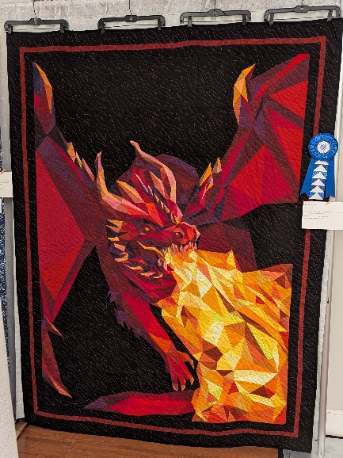 | 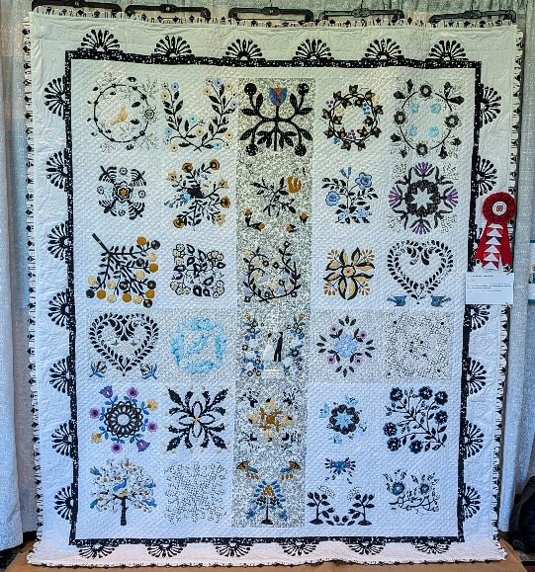 | 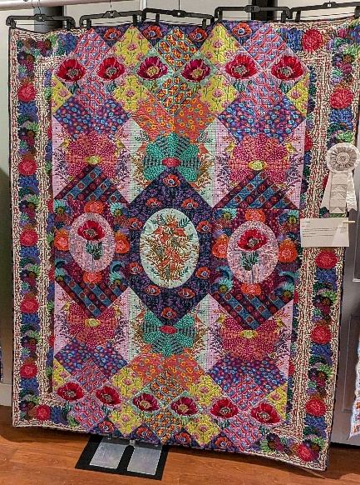
1st Place - Coralyn Colladay, "Grimwoirren's Pet" | 2nd Place – Nancy Zachik, “Claire and Matt’s Wedding Quilt” | 3rd Place – Susan H., “Visions”

Medium Quilts
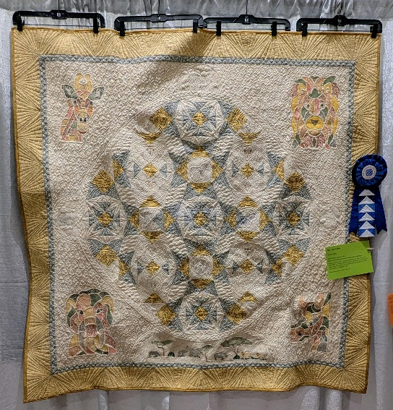 | 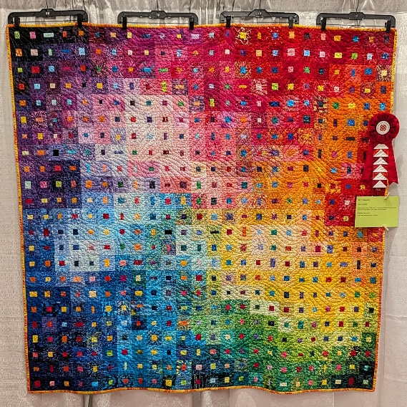 | 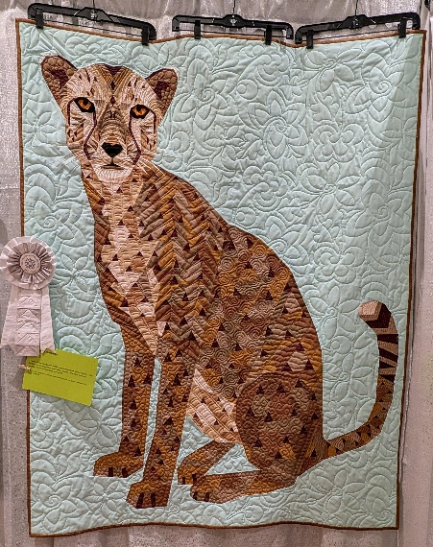
1st Place – JoAnn DuChez, “Ode to Africa” | 2nd Place – Alison Leukefeld, “Colorwash I” | 3rd Place – Karen Moss, “Cheetah Abstractions”

Small Quilts
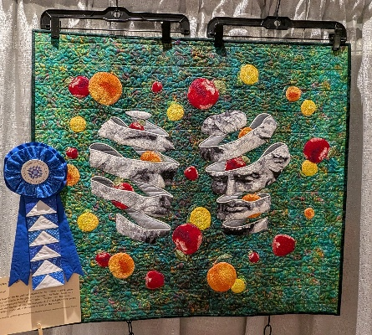 | 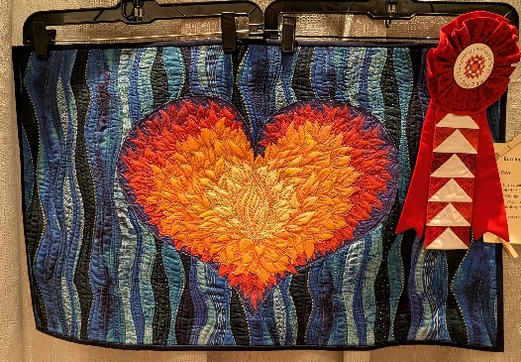
1st Place – Peggy Weidman, “Food for Thought” | 2nd Place – Stacy Ross, “Burning Orange and Blue”
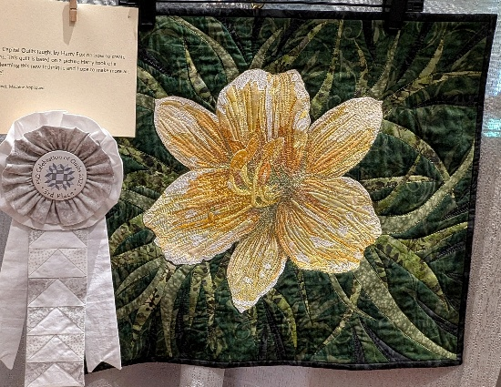 | 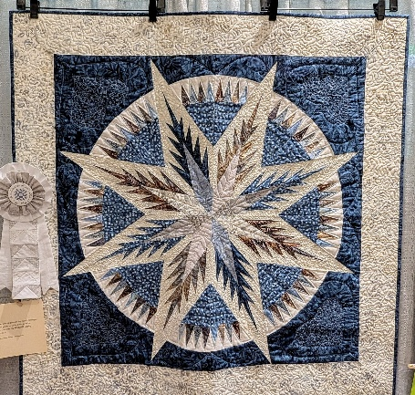
3rd Place (Tie) – Stacy Ross, “Yellow Lily” | 3rd Place (Tie) – Lisa Wells, “Antique Lighthouse”

Miniature Quilts
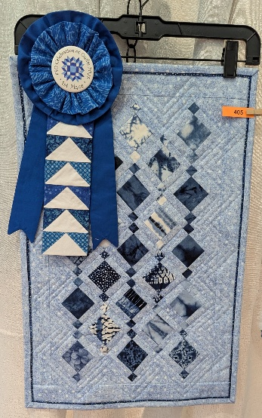 | 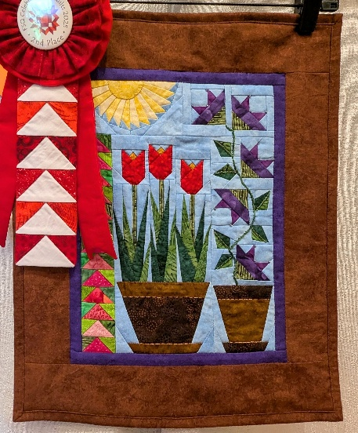 | 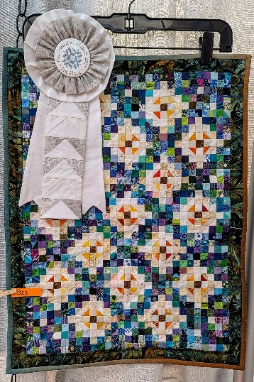
1st Place – Suma Glassman, “Blue Baby Beads” | 2nd Place – Mary Ann Bruce, “My Paper Pieced Garden” | 3rd Place – Barbara Skelly, “Make Mine a Mini”

Other
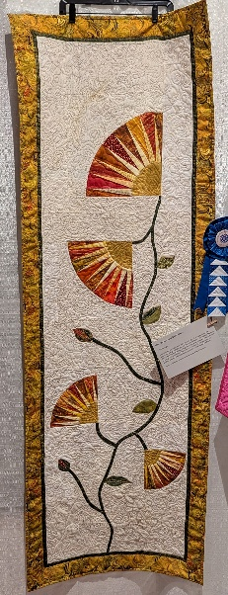 | 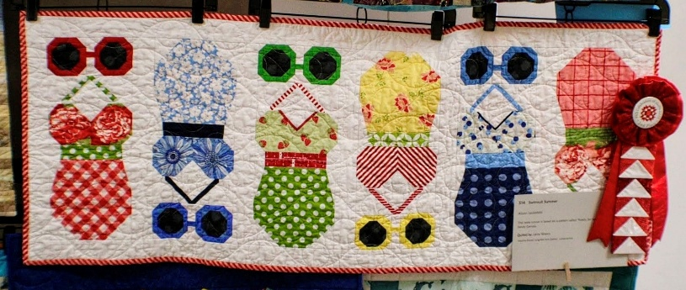 | 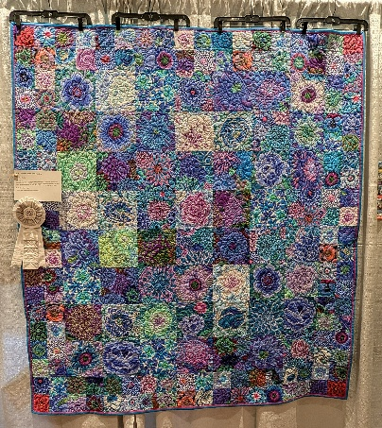
1st Place – Trish McTighe, “My Maryland Spring Beauty” | 2nd Place – Alison Leukefeld, “Swimsuit Summer” | 3rd Place – Gretchen Golas, “Blue Seed Packet Wall Hanging”

Log Jam Challenge
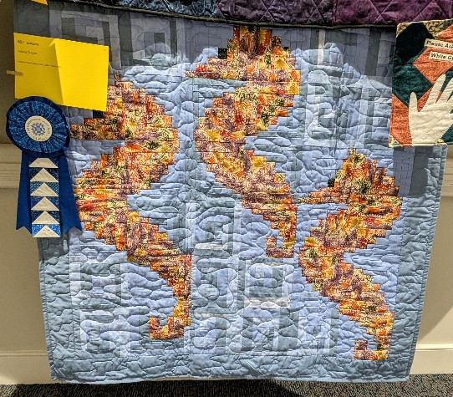 | 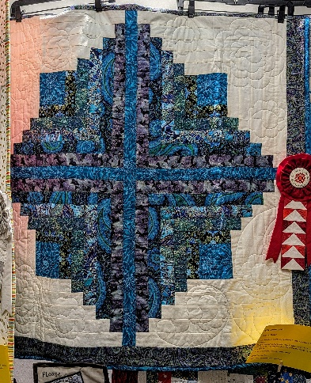 | 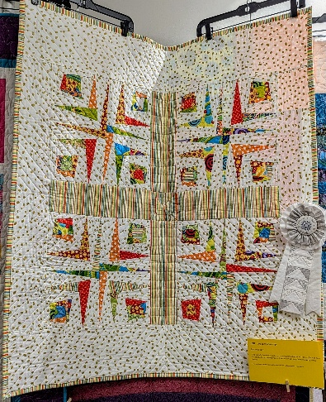
1st Place – JoAnn DuChez, “Seahorses” | 2nd Place – Mary Lou Dungan, “Blueberry Jam” | 3rd Place – Barbara Skelly, “Log Jam Challenge”

“Life’s a Beach” Guild Challenge
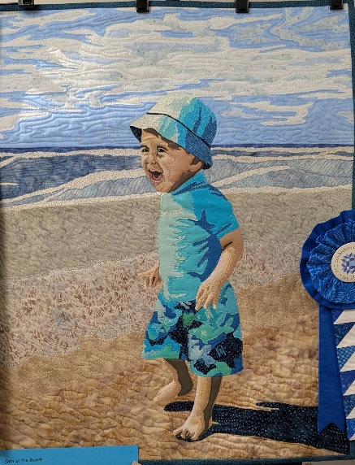 | 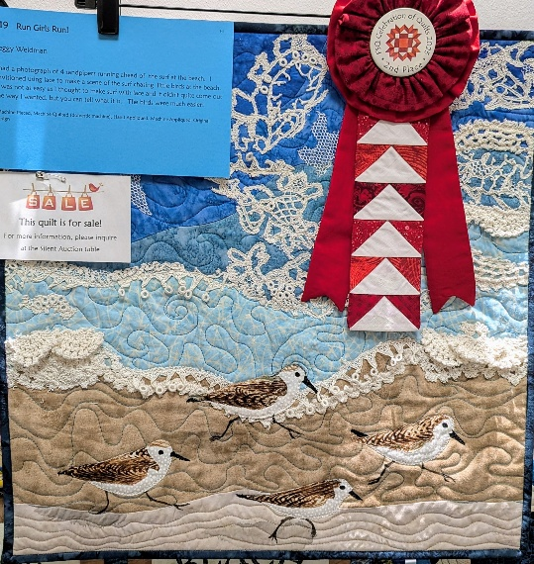 | 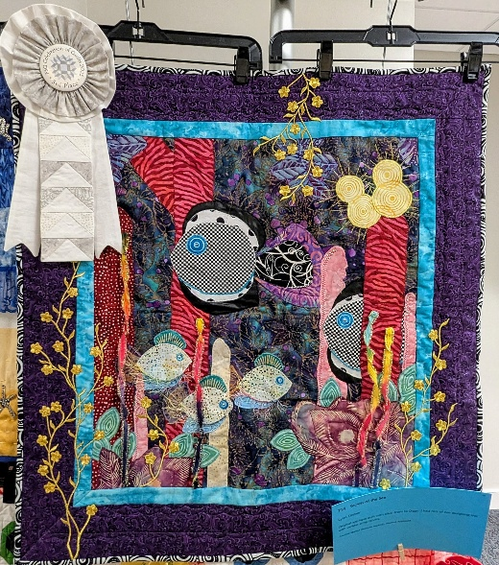
1st Place – Stacy Ross, “Sam at the Beach” | 2nd Place – Peggy Weidman, “Run Girls Run!” | 3rd Place – Lynn Stieber, “Secrets of the Sea”

